**Insert School Logo**

**Semester One**

**Examination 2019**

**Question/Answer booklet**

**MATHEMATICS**

**METHODS UNIT 1**

**Section Two:**

**Calculator–assumed**

|  |
| --- |
| Student Name: _____________________________________ |
| Teacher’s Name: _____________________________________ |

**Time allowed for this section**

Reading time before commencing work: ten minutes

Working time for paper: one hundred minutes

**Material required/recommended for this section**

**To be provided by the supervisor**

This Question/Answer booklet

Formula Sheet (retained from Section One)

**To be provided by the candidate**

Standard items: pens (blue/black preferred), pencils (including coloured), sharpener, correction tape/fluid, erasers, ruler, highlighters

Special Items: drawing instruments, templates, notes on two unfolded sheets of A4 paper, and up to three calculators approved for use in the WACE examinations.

**Important note to candidates**

No other items may be taken into the examination room. It is **your** responsibility to ensure that you do not have any unauthorised notes or other items of a non–personal nature in the examination room. If you have any unauthorised material with you, hand it to the supervisor **before** reading any further.

**Structure of this paper**

|  |  |  |  |  |  |
| --- | --- | --- | --- | --- | --- |
|  | Number of questions available | Number of questions to be attempted | Working time (minutes) | Marks available | Percentage of exam |
| Section One  Calculator—free | 8 | 8 | 50 | 50 | 35 |
| **Section Two**  **Calculator—assumed** | **15** | **15** | **100** | **100** | **65** |
|  | | | | Total Percentage | 100 |

**Instructions to candidates**

1. The rules for the conduct of Western Australian external examinations are detailed in the

*Year 12 Information Handbook 2019.* Sitting this examination implies that you agree to abide by these rules.

1. Answer the questions according to the following instructions.

**Show all your working clearly.** Your working should be in sufficient detail to allow your

answers to be checked readily and for marks to be awarded for reasoning. Incorrect answers given without supporting reasoning cannot be allocated any marks. For any question or part question worth more than two marks, valid working or justification is required to receive full marks. If you repeat an answer to any question, ensure that you cancel the answer you do not wish to have marked.

It is recommended that you **do not use pencil**, except in diagrams.

1. You must be careful to confine your responses to the specific questions asked and to follow any instructions that are specific to a particular question.
2. Spare pages are included at the end of this booklet. They can be used for planning your responses and/or as additional space if required to continue an answer.

* Planning: If you use the spare pages for planning, indicate this clearly at the top of the page.
* Continuing an answer: If you need to use the space to continue an answer, indicate in the original answer space where the answer is continued, i.e. give the page number. Fill in the number of the question that you are continuing to answer at the top of the page.

1. The Formula Sheet is **not** handed in with your Question/Answer Booklet.

# Section Two: Calculator–assumed 65% (100 marks)

This section has **fifteen (15)** questions. Attempt **all** questions. Write your answers in the spaces

provided.

Spare pages are included at the end of this booklet. They can be used for planning your responses

and/or as additional space if required to continue an answer.

* Planning: If you use the spare pages for planning, indicate this clearly at the top of the page.
* Continuing an answer: If you need to use the space to continue an answer, indicate in the original answer space where the answer is continued, i.e. give the page number. Fill in the number of the question(s) that you are continuing to answer at the top of the page.

Working time: 100 minutes

**Question 9 (5 marks)**

When 

Determine:

(a) the value of n. (1 mark)

(b) the value of b. Show your working. (2 marks)

Hence;

(c) determine the fifth term. Show your working. (2 marks)

**Question 10 (5 marks)**

(a) On an evening in Perth the temperature (T°C) of a particular solid was inversely proportional to the square of the number of hours (t) after 7 pm.

At 9 pm the temperature was 12°C.

Determine:

(i) the constant of proportionality. (2 marks)

(ii) the temperature, correct to the nearest degree, at 11:45 pm. (2 marks)

(b) Which of the following sketches, A, B, C or D are displaying direct proportion? (1 mark)

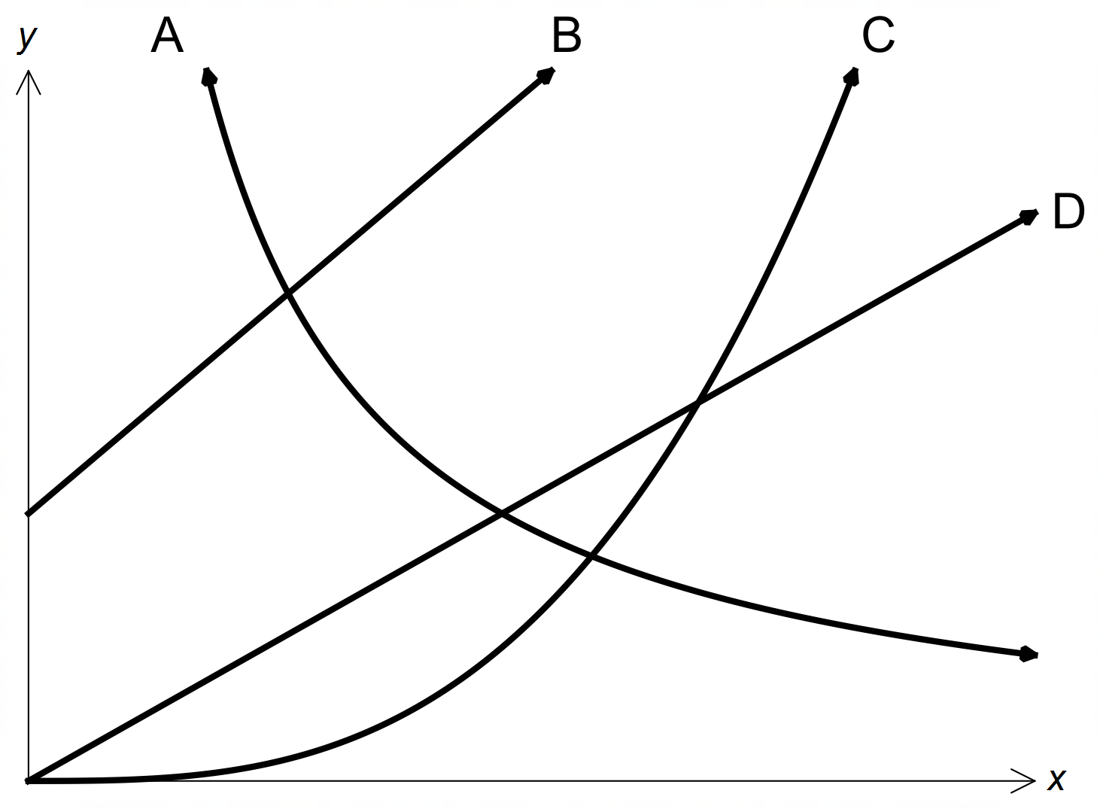

**Question 11 (7 marks)**

(a) Determine the value of *a*, correct to 2 decimal places. (2 marks)

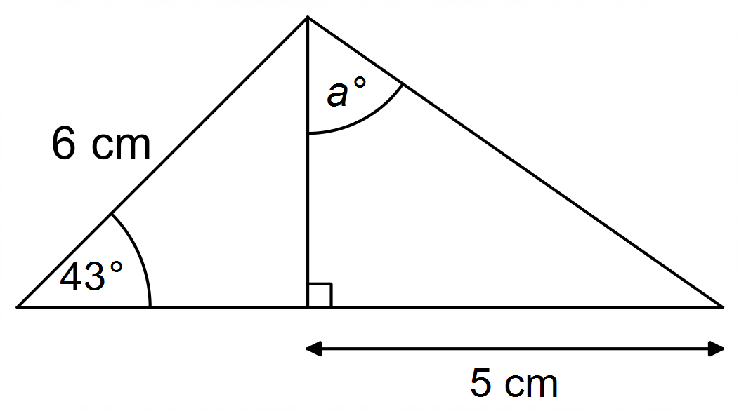

(b) The shaded major segment of the circle with centre O below has an area of 54 cm2.

The length of major arc ABC is 24 cm.

Determine the radius of the circle. (5 marks)

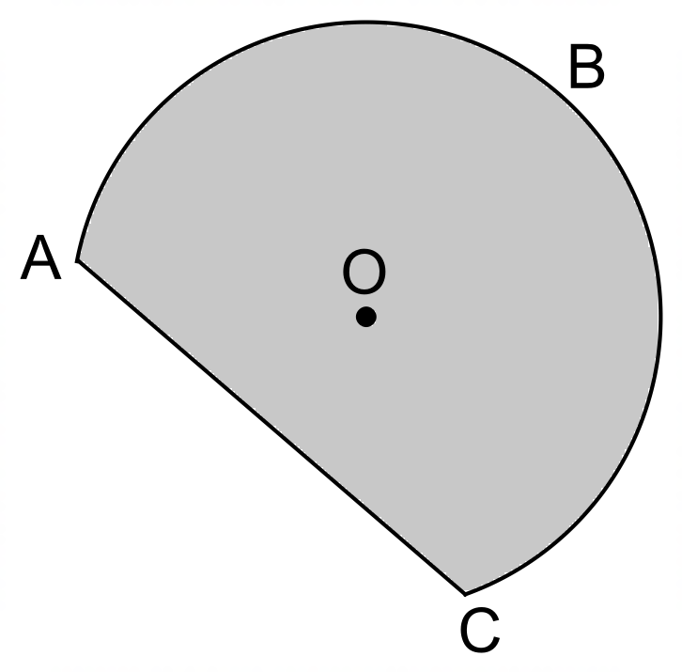(Hint: Let 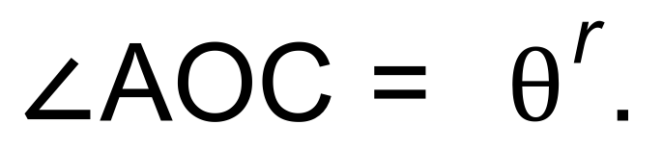 )

**Question 12 (8 marks)**

Determine the equations of each of the following trigonometric graphs.

(a) (2 marks)

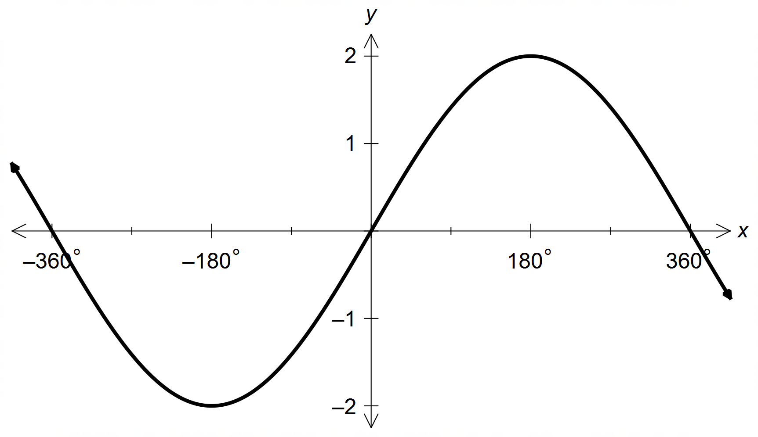

(b) (3 marks)

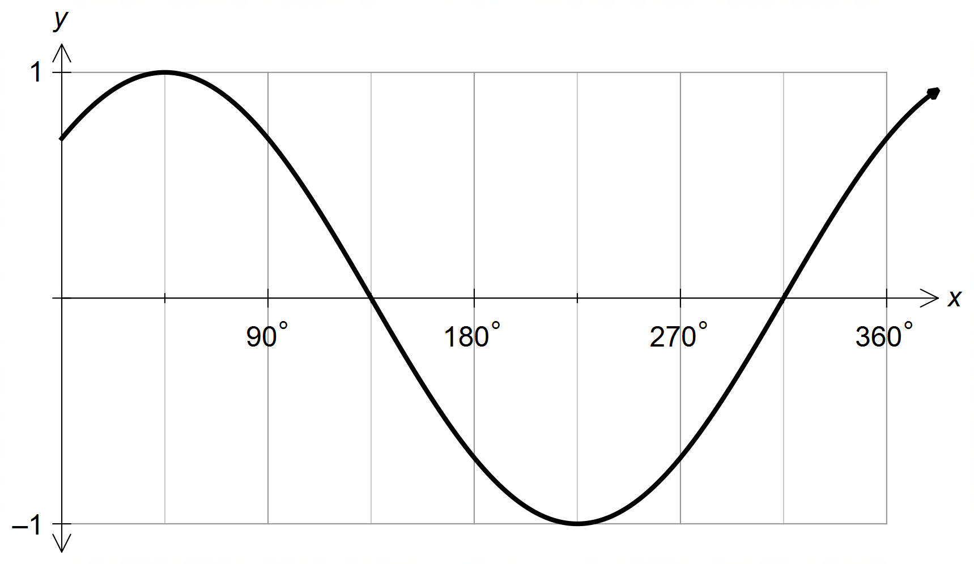

(c) (3 marks)

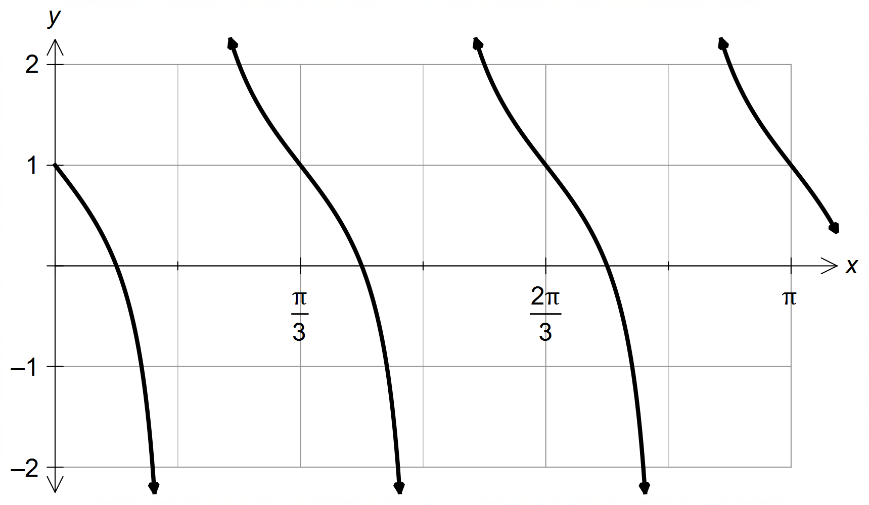

**Question 13 (8 marks)**

The equation of a diameter 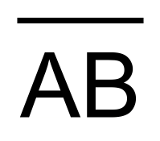, of a circle with centre (2, 6), is given as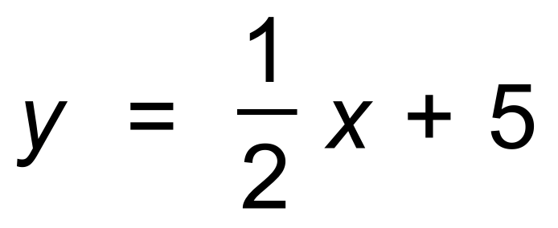.

The equation of chord, 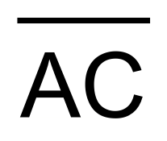is given as 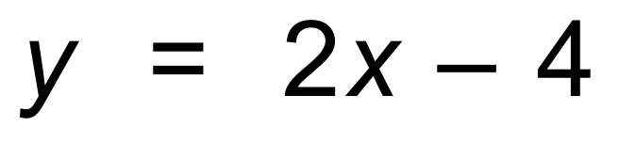.

(a) Determine the co−ordinates of A. (3 marks)

(b) State the co−ordinates of B. (2 marks)

Hence, or otherwise;

(c) determine the co−ordinates of C. (3 marks)

**Question 14 (6 marks)**

(a) (i) Show that 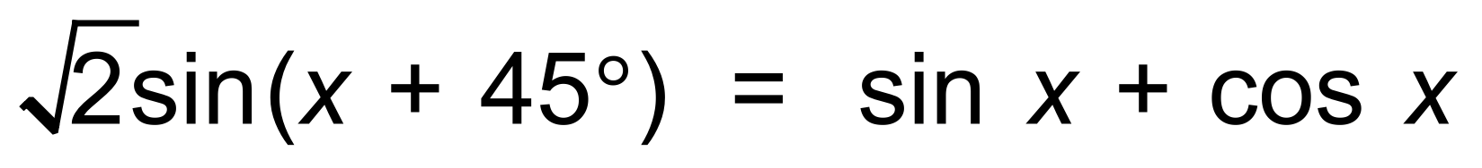. (2 marks)

Hence,

(ii) show that the exact value of 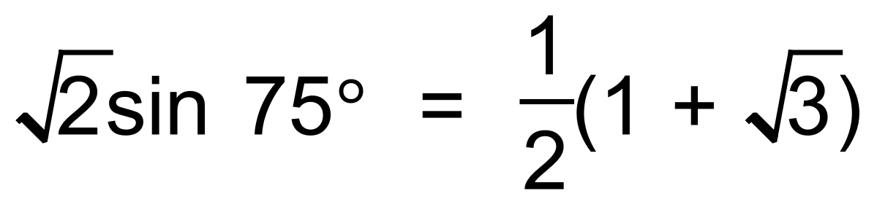 (2 marks)

(b) Simplify 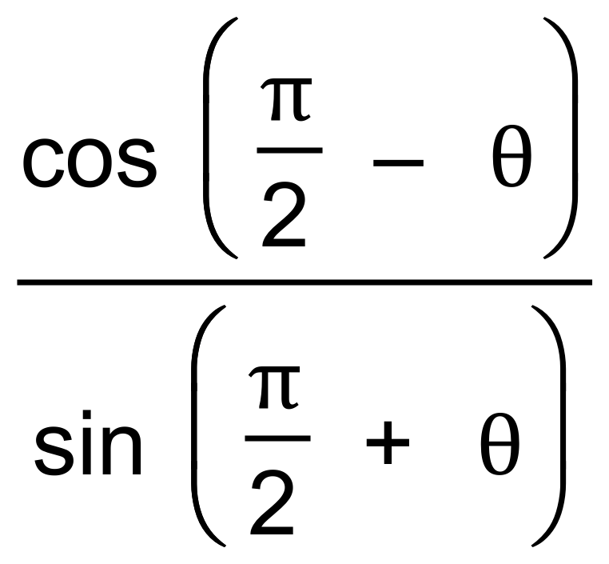 (2 marks)

**Question 15 (8 marks)**

A roller−coaster has two sections of its track given below where h(x) is the **vertical height above the starting point of the coaster**, and t is the time, in seconds, after the coaster leaves that starting point.

Section A: 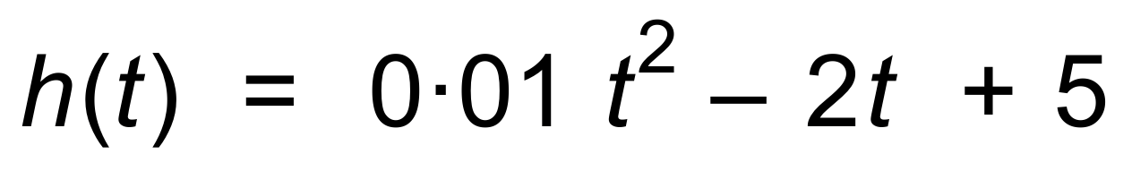

Section B: 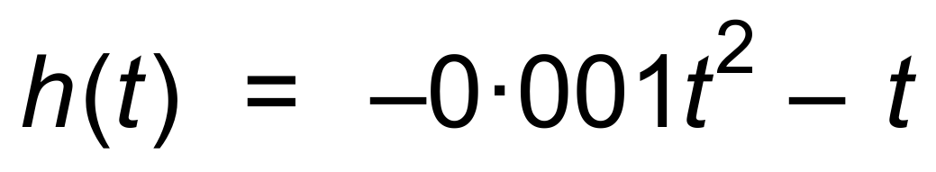

(a) In which section does the roller−coaster begin? Explain. (2 marks)

(b) When, correct to one decimal place, do the two sections join?

Show your reasoning. (2 marks)

(c) What is the lowest point, to the nearest metre, that the coaster descends?

Explain. (2 marks)

(d) When, to the nearest second, will the coaster be at the same height as it was initially?

Explain clearly. (2 marks)

**Question 16 (6 marks)**

The graph of 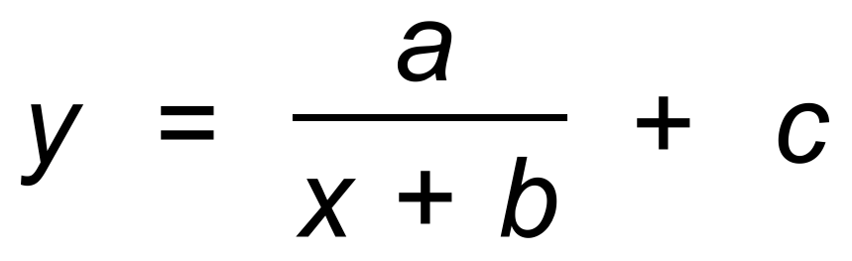 is drawn below.

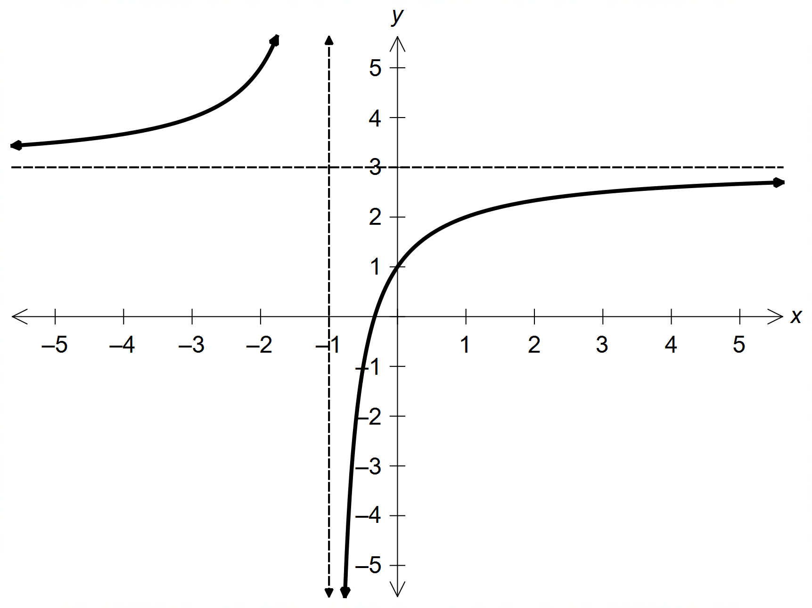

(a) Determine the values of a, b and c. (4 marks)

(b) On the same axes, sketch the linear function with y−intercept of 1 and

angle of inclination of 135°. (2 marks)

**Question 17 (5 marks)**

The height of the tide at the entrance of a harbour on a particular day is given by the equation

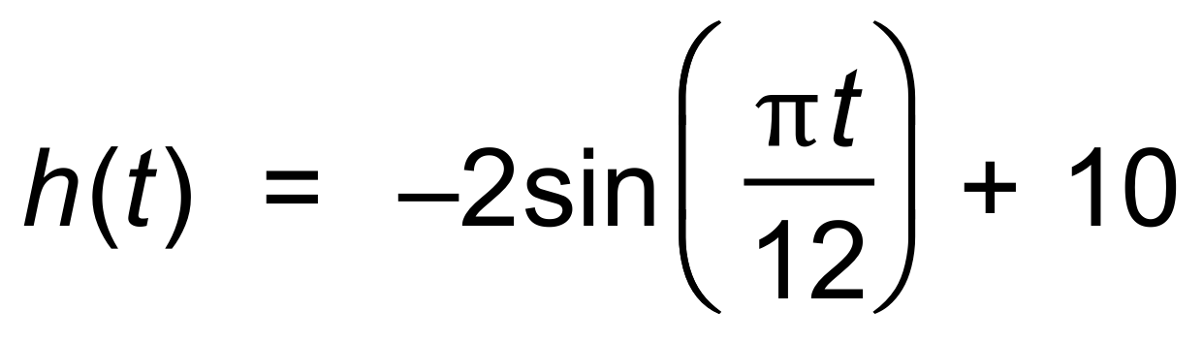 where *t* is the number of hours after 12 midnight, and *h* is the number of metres above the sea bed.

(a) Determine:

(i) the height, to one decimal place, of the tide above the sea bed at 3 am. (1 mark)

(ii) the time(s) of high tide. (1 mark)

A ship is to berth at the harbor. It requires the height of the tide to be at least 9 metres above the sea bed.

(b) During what times of the day will the ship be unable to enter the harbour?

Show your reasoning clearly. (3 marks)

**Question 18 (6 marks)**

A portion of Pascal’s Triangle is shown below.

Row 0 1

Row 1 1 1

Row 2 1 2 1

Row 3 1 3 3 1

Row 4 1 *a* *b* *c* 1

Row 5 1 *d e f g* 1

Determine:

(a) the values of *b* and *f*. (1 mark)

(b) an equation relating *b*, *c* and *f*. (1 mark)

(c) the number of terms in Row 12. (1 mark)

The third term of Row 5 is *f*.

(d) State the fifth term of Row 8, using the notation 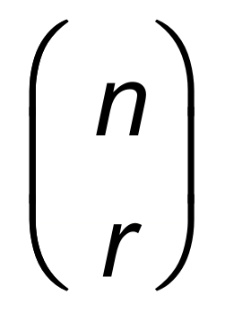. (1 mark)

The terms highlighted within the ellipse can be defined using a quadratic equation involving *m*, the number of the term of the sequence. 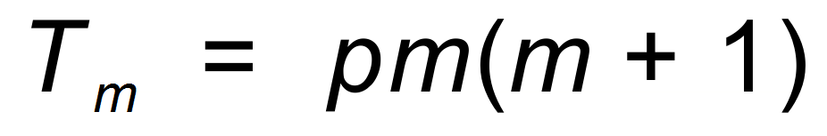.

(e) Determine *p*. (2 marks)

**Question 19 (10 marks)**

A pencil case contains ten pens; three red pens, five blue pens and two black pens.

Ian was asked to select five pens from the pencil case.

(a) How many different selections can Ian make with regard to colour that contain:

(i) exactly three blue pens? (2 marks)

(ii) more black pens than red pens? (2 marks)

(b) Ian was asked to make a selection of five pens and the solution was 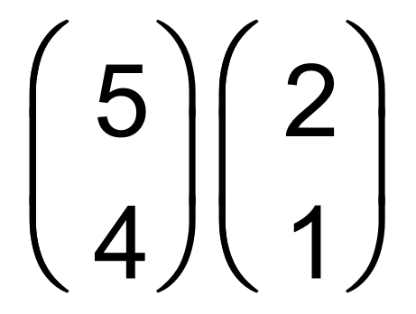.

What selection was Ian asked to make? (2 marks)

(c) Find the probability that Ian chooses:

(i) at least one red pen. (2 marks)

(ii) at most two red pens, given he chooses at least one red pen. (2 marks)

**Question 20 (7 marks)**

A vacant block in the shape of the quadrilateral ABCD, is shown below, with measurements in metres.

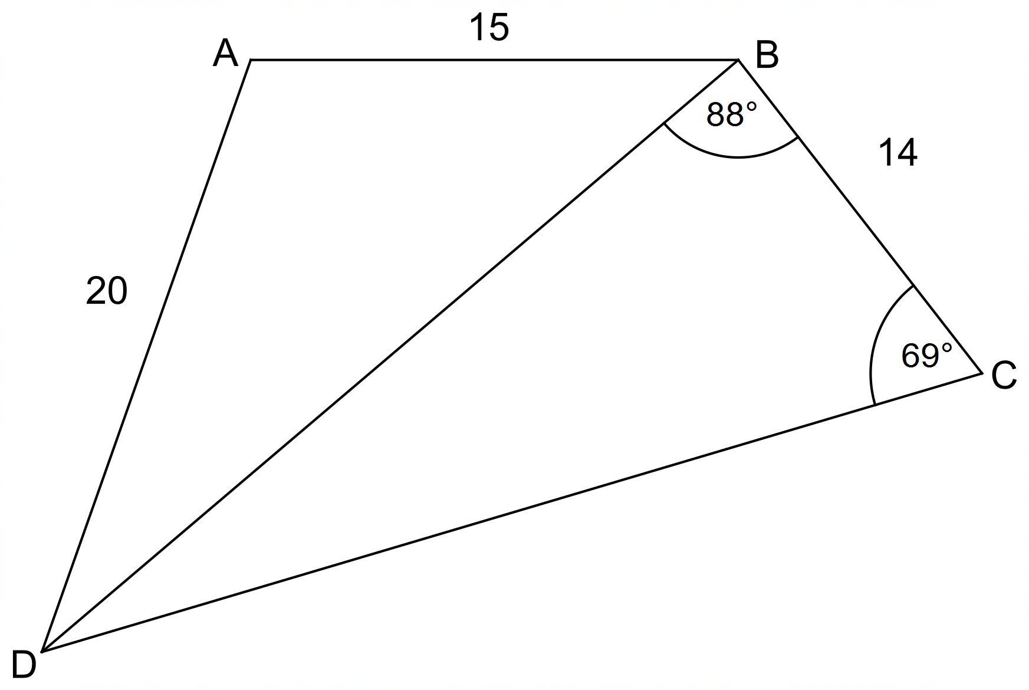

(a) Determine, with working;

(i) the length of DB, correct to the nearest metre. (2 marks)

(ii) the size of ∠ABD, correct to two decimal places. (2 marks)

Hence, or otherwise,

(b) state the area of the block. Show your working. (3 marks)

**Question 21 (6 marks)**

(a) Use the Venn diagrams below to shade the indicated regions.

(i) A ∪ B′ (ii) B ∩ (C ∪ A)′ (4 marks)

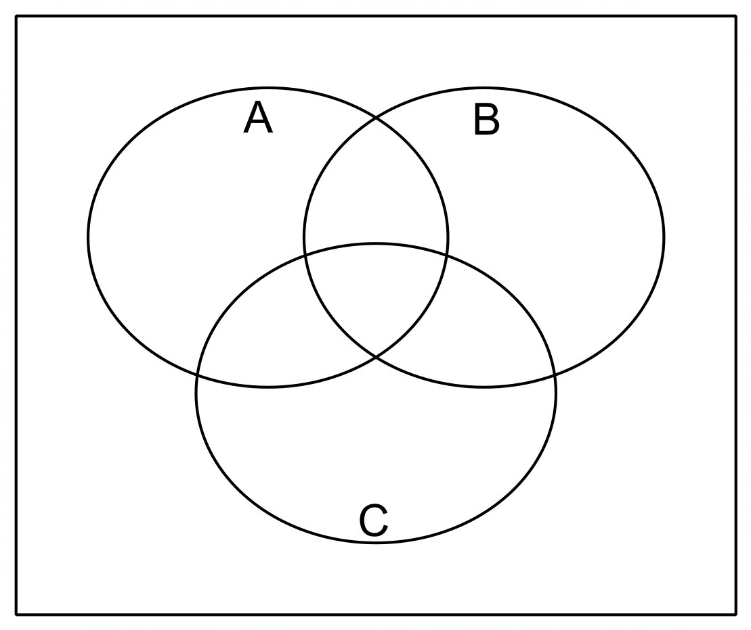

(b) Use set notation to describe the region shaded. (2 marks)

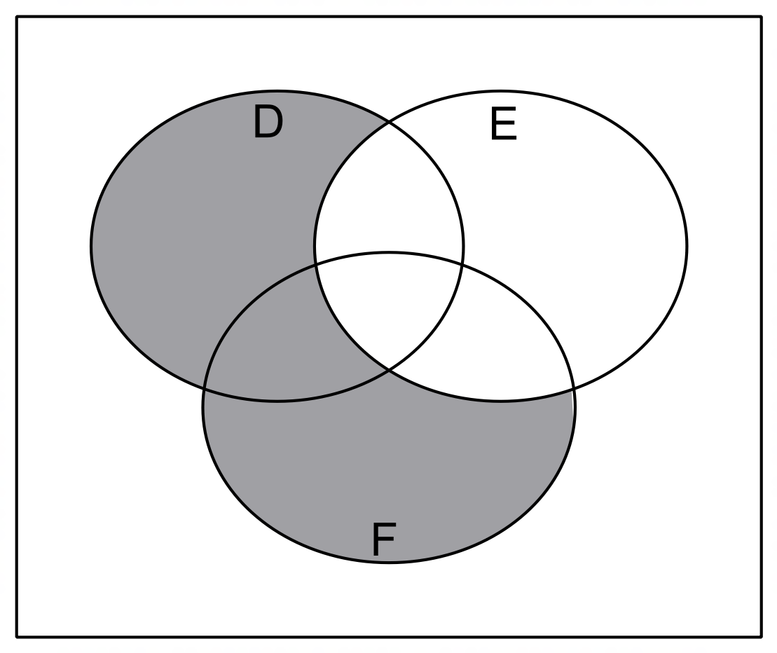

**Question 22 (8 marks)**

Graham travels to work each day of the working week by car.

He passes through three sets of lights in his journey.

The probability that he stops at the first set of lights is 0.7, while the probability that he doesn’t stop at the second set of lights is 0.65.

The probability that he stops at the second set of lights given he stops at the first set of lights is 0.35

The probability that he stops at the third set of lights is 0.4, which is independent of stopping at the earlier sets of lights.

(a) Are the events “stops at the first set of lights” and “stops at the second set of lights”

independent events? Explain clearly using mathematical notation. (2 marks)

(b) Determine the probability that Graham:

(i) stops at every set of lights. (2 marks)

(i) stops at either the first set or second set of lights or both. (2 marks)

(iii) doesn’t stop at any set of lights, given he didn’t stop at the first set of lights. (2 marks)

**Question 23 (5 marks)**

A survey was conducted at the local high school concerning health food in their canteen.

The question posed was; “Should the canteen introduce more health food?”

The results are shown in the table below.

|  |  |  |
| --- | --- | --- |
|  | Yes | No |
| Year 7 & 8 | 85 | 15 |
| Year 11 & 12 | 40 | 60 |
| Total | 125 | 75 |

A student is selected at random from the two hundred students surveyed.

(a) Determine the probability that the student:

(i) voted Yes or was from Year 11 or 12. (1 mark)

(ii) was from Year 7 or 8, given that the student voted Yes. (2 marks)

(b) The events “Introduce more health food” and “School Year” are not

independent events according to this survey.

Explain, using entries from the table why this is the case. (2 marks)

**End of questions**

**Additional working space**

Question number(s): ……………………

**Additional working space**

Question number(s): ……………………